Simpact Documentation

Contents

An Overview 1

Purpose 1

Entities, State Variables, and Scales 1

Process Overview and Scheduling 2

Design Concepts 2

Initialization 2

Submodels 3

Getting Starting 6

Initial Population Parameters 7

Event Parameters 8

Generating output 16

Graphs 16

Population CSV 19

Relations CSV 20

Trans CSV 21

More Advanced Use 21

# An Overview

Simpact is an event-driven individual-based model that is based on[1] the modified next reaction method (mNRM) algorithm[2], a derivative of the Gillespie Stochastic Simulation algorithm[3]. Its main purpose is to ***S***imulate the ***impact*** of HIV. This documentation first gives a description of the model following the standard protocol identified by Grimm et al[4]. This protocol is known as ODD (Overview, Design concepts, and Details) and involves seven elements that form the structure of our Methods description. Next we describe how to use Simpact, the intial parameters of the program, and how to generate output from the GUI. Last we describe writing Simpact scripts, or “more advanced use”.

## Purpose

The model was designed to explore the spread of human immunodeficiency virus (HIV) infections in complex and dynamic sexual networks. We wanted to be able to answer: which attributes contribute significantly to the diffusion of HIV, and what intervention can be most effective in interrupting this diffusion.

## Entities, State Variables, and Scales

The model considers two kinds of agents: males and females. Both kinds of agents have a notion of who his or her

1. Father
2. Mother
3. Birth time
4. Time of death
5. Whether the death was AIDS related
6. The time of infection (if infected during the simulation)
7. The source of HIV infection (if infected during the simulation)
8. The starting and stopping times for ARV treatment
9. The community to which he or she is member of
10. Whether they were exposed to a behavioural change campaign
11. Partnering ???

Additionally males have the concept of time of circumcision (if circumcised at all) and consistency of condom use. Females have the notion of whether or not she is pregnant. The number of males and females, and the duration of simulation is not specified a priori.

## Process Overview and Scheduling

Events occur one at a time according to the modified next reaction method (mNRM). The events are follows:

1. AIDS Mortality
2. Antenatal Care
3. ARV Treatment
4. ARV Stop
5. Birth
6. Male Circumcision
7. Conception
8. Dissolution
9. Formation
10. HIV Introduction
11. MTCT Transmission
12. Non-AIDS Mortality
13. HIV Test
14. HIV Transmission

Events are scheduled to occur relative to the events specific cumulative hazard function. Each event *k* has its own cumulative hazard function $h^{k}\left(X\left(t\right),t\right)$ that considers the current state of the system $X\left(t\right)$ (specifically which components are described later) at time *t*, and the current time *t* of the simulation. The order of events is significant since the firing of one event may enable or change another.

We briefly describe here the mNRM. At initiation we assign each event *k* an internal clock time $T_{k}$ = 0 and time till first firing $P_{k}=\ln\left(\frac{1}{r_{k}}\right)$, where $r_{k}$ is uniformally distributed random number between 0 and 1. For each event *k* we calculate next firing time $Δ_{k}$

$\int_{0}^{Δ_{k}}{h^{k}\left(X\left(0\right),s\right) ds }=P_{k}-T_{k}=P_{k}$ (1)

Where $(X\left(0\right)$ is the state of the system at time 0 (including all parameters specific to the hazard function). In words, this is the time at which the cumulative hazard reaches the random value $P_{k}$. The next to fire then is the event $μ$ for which $Δ_{μ}=\min_{∀k}({Δ_{k}})$.

We then update the system to reflect the consequences of event $μ$ and update the time *t* to be $Δ_{m}$. Event $μ$ is given a new value for $P_{μ}=\ln\left(\frac{1}{r_{μ}}\right)$, and every other event’s internal clock is update $T_{k}=T_{k}+\int_{t}^{t+Δ_{m}}{h^{k}\left(X\left(t\right),s\right) ds}$. The algorithm is repeated of finding the event with the minimum next firing time. The algorithm is written in psuedocode below:

1. Set $t=0 \text{and }T_{k}=0$ for each event *k*, and initialize population $X\left(t\right)$
2. Calculate the hazard function $h^{k}$ for each event *k*
3. Generate a random $P_{k}=\ln\left(\frac{1}{r}\right)$ where *r* is uniform(0,1).
4. While not done:
   1. Find $Δ_{k}$ for each event via (1)
   2. Let $Δ_{μ}=\min\left(Δ_{k}\right)$%the time till the next event (event $μ$) is fired
   3. Set $t=t+Δ_{μ}$
   4. Set the population $X\left(t\right)$ according to event $μ$.
   5. Update $h^{k}$ if event *k* is dependent on event $μ$.
   6. Set $T_{k}=T_{k}+Δ_{μ} ∀k$
   7. Set $P_{μ}=\ln\left(\frac{1}{r}\right)$

The dependencies of events is given in the fire-enable chart Figure 1.

## Design Concepts

This model simulates the spread of HIV in complex sexual networks: events are individual based (circumcision is set to occur for most individuals at age 15, relationships among individuals consider individual level desirability of concurrency, age-disparity, time-since-infection infectivity, etc.). This allows us to investigate the dynamics of an epidemic at a fine grain level. Being able to model the epidemic allows us to additionally model intervention methods and their potential effectiveness.

## Initialization

At initialization a variable[5] number of individuals is created. The age and sexual partnering characteristics are based on empirical survey data[6]. Relationships are allowed to form and dissolve until relationship dynamics are in a steady-state (usually two years). HIV is then introduced into the system through infecting 10 randomly selected individuals.

## Submodels

As mentioned earlier, each event is characterized by it’s own hazard function. The hazard function for each event is in Table 1 below. Comments describe each variables. Variables without a description are constants with initial values described later in the “Event Parameters” section. Each is a function of *t*, the time of the simulation.

AIDS_mortality

antenatal_care

ARV_treatment

ARV_stop

birth

male_circumcision

conception

dissolution

formation_BCC

HIV_introduction

MTCT_transmission

non_AIDS_mortality

HIV_test

HIV_transmission

**FIRE ENABLE CHART**

Figure 1: A graphical depiction of all the events possible in Simpact and how the firing of one affects the enabling of another. For example when an individual is tested for HIV (the HIV_test for that individual is fired) than the event that he or she begins treatment is created (ARV_treatment is enabled).

|  |  |  |
| --- | --- | --- |
| **Event** | **Hazard Function** | **Comments** |
| AIDS Mortality | $$h_{i}\left(t\right)=\frac{κ}{λ}{\left(\frac{t-I_{t}}{λ}\right)}^{κ-1}$$ | * Hazard of individual *i* death $κ$* is the shape factor (Weibull distribution) $λ$* is the scale factor (Weibull distribution) $I_{i}$* is the time of infection of individual *i* [( $t-I_{i})$ is the time since infection] |
| Antenatal Care |  |  |
| ARV Treatment |  |  |
| ARV Stop |  |  |
| Birth | (no hazard) | * Birth occurs approximately 9 months after conception, unless mother dies first |
| Male Circumcision | $$h_{i}\left(t\right)=\frac{x}{πγ\left(\frac{t-t_{p}-b_{i}}{γ}+1\right)}$$ | * Hazard of individual *i* being circumcised * *x* is the scaling factor (Cauchy distribution) $γ$* is the spread factor (Cauchy distribution) $t_{p}$* is the peak age of circumcision $b_{i}$* is the birth time of the individual *i* |
| Conception |  |  |
| HIV Introduction | (no hazard) |  |
| Formation | (hazard of formation between male *i* and female *j* ) | * The hazard of forming a relationship between individual *i* and individual *j* * *x* is the combined number of current relations, * *y* is the mean age of the couple, * *z* is the time since last change in relationship status (the last time either the male or female was an actor in a formation or dissolution event), * *m* is the male age, * *f* is the female age, * *o* is the preferred age difference. |
| Dissolution | (same as above) | (same as above) |
| MTCT Transmission |  |  |
| Non-AIDS Mortality |  |  |
| HIV Test |  |  |
| HIV Transmission | $$h_{ij}\left(t\right)=$$ $\left(α+β_{1}I_{1}+β_{2}I_{2}\right)\left(1-β_{3}C\right)\left(1-β_{4}M\right)\left(1-β_{5}A\right)$ | * The hazard of transmission from individual *i* to individual *j $α$* * is the “baseline” hazard of transmission within a couple that is not using condoms, where the infected partner is in the chronic stage of HIV infection and not on ARVs, and, in the case of the male partner being infected, the male is not circumcised, $β_{1} \text{and }β_{2}$* are values to augment the baseline hazard in the case that the infected partner is in the acute or late stage of infection, as indicated by the indicator variables $I_{1} \text{and }I_{2}$, $β_{3}, β_{4}, \text{and }β_{5}$* are the amount infectiousness is decreased by if individual *i* uses condoms, is circumcised, or is on ARV respectively which is indicated by the indicator variables *C, M,* and *A* respectively. |

Table 1: Hazard function of each event and description of parameters.

Getting Starting

Working with Simpact’s GUI

Simpact was developed to make the simulation of HIV in complex sexual network simple and easy. To this end the graphical user interface (GUI) lets a user easily set parameters of the model. To run the GUI on a windows machine, double-click “RUN_SIMPACT.bat”.

If you’re using a mac or Linux OS, you can start the GUI by typing “run_simpact.m” into the Matlab command window. Make sure that your current working directory in Matlab is set to Simpact’s home directory. An example of what you should see is in **Figure 2**.

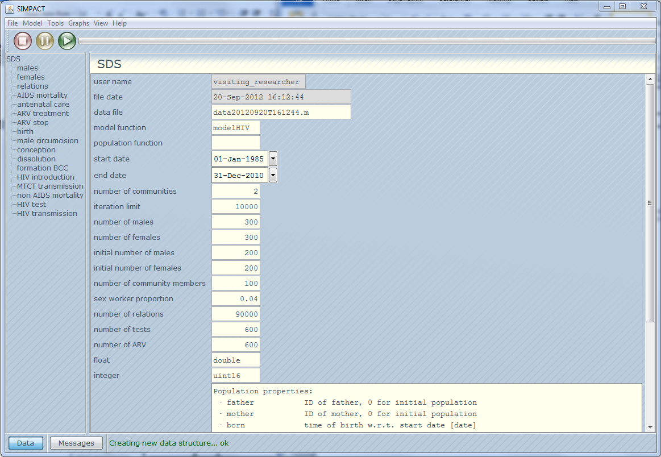

Figure 2: The graphical user interface for Simpact. Users can set parameters and run the simulation from this window.

From this main window you can start, stop, and pause the simulation with , , and  buttons.

The number of parameters can be somewhat overwhelming at first, but many are intuitive and even many others are not used by default. There are a few different parameters: population, event, and intervention. Below we present a short description of each.

## Initial Population Parameters

These parameters describe the population which we are simulating. [expand?]

**data file:** The file to which data will be written after the simulation. The default value is a convoluted mess of numbers that indicates the date and time of the simulation. This can be changed to a more practical name.

**model function:** The engine for Simpact is ‘modelHIV’. Other engines could theoretically be created to model other complex processes such as heart disease, but have not yet.

**population function: ?**

**start date:** The starting date of the simulation.

**end date:** The ending date of the simulation.

**number of communities:** [Wim?]

**iteration limit:** The simulation will terminate if this limit is reached even if the end date has not been reached yet.

**number of males:** The upper bound for the number of males that will be in the system.

**number of females:** The upper bound for the number of females that will be in the system.

**initial number of males:** The starting number of males in the system.

**initial number of females:** The starting number of females in the system.

**number of community members: ???**

**sex worker proportion: ???**

**number of relations:** The upper bound on the number of relationships**.**

**number of tests: ???**

**number of ARV: ???**

**float: ???**

**integer: ???**

## Event Parameters

The events are what happen in the simulation. Each event has the basic properties:

**object_type:** ‘event’

**enable:** 1

**event_file:** The file where the functions associated with this event are.

**comments:** Notes about the event.

The only changeable parameter is “**enable**” which can be set to 0 in order to “disable” it (not include it in the simulation). Some events, such as AIDSmortality, have only the basic properties but nothing else. Other events, such as HIVtest, have many more. Below is a table with a description of each event and their properties:

|  |  |  |
| --- | --- | --- |
| **Event** | **Initial Value** | **Description** |
| **AIDSmortality** |  |  |
| *object_type* | 'event' | When an individual becomes infected, an AIDSmortality event is created for him or her. |
| *enable* | 1 |  |
| *event_file* | 'eventAIDSmortality' |  |
| *comments* | {'AIDS mortality properties implemented by HIV transmission event.'} |  |
| **AntenatalCare** |  |  |
| *object_type* | 'event' |  |
| *enable* | 1 |  |
| *event_file* | 'eventANC' |  |
| *attendance* | {3x4 cell} |  |
| *comments* | {'Antenatal care implemented by ANC event.'} |  |
| **ARVtreatment** |  |  |
| *object_type* | 'event' |  |
| *enable* | 1 |  |
| *event_file* | 'eventARV' |  |
| *ARV_program_start_time* | 15 |  |
| *lifetime_extension_by_ARV* | {2x2 cell} |  |
| *comments* | {'Treatment implemented by ARV event.'} |  |
| **ARVstop** |  |  |
| *object_type* | 'event' |  |
| *enable* | 1 |  |
| *event_file* | 'eventARVstop' |  |
| *drop_out_rate* | 0.05 |  |
| *lifetime_extension_by_ARV* | {2x2 cell} |  |
| *comments* | {'Treatment implemented by ARVstop event.'} |  |
| **birth** |  |  |
| *object_type* | 'event' | When a conception event fires, a birth is fired after the prescribed gestation period (0.76 of a year is approximately 9 months). |
| *enable* | 1 |  |
| *event_file* | 'eventBirth' |  |
| *boy_girl_ratio* | 0.5 |  |
| *gestation* | 0.76923 |  |
| *comments* | {'Every pregnant woman gives birth, unless mortality occurs first'} |  |
| **malecircumcision** |  |  |
| *object_type* | 'event' |  |
| *enable* | 1 |  |
| *event_file* | 'eventCircumcision' |  |
| *Cauchy_scale_parameter* | 1 |  |
| *Cauchy_peak_age* | 40 |  |
| *campaign_scale_factor* | 1 |  |
| *campaign_start_date* | '01-Jan-2050' |  |
| *campaign_roll_out_duration* | 2 |  |
| *time_vector_resolution* | 0.5 |  |
| *comments* | {''} |  |
| **conception** |  |  |
| *object_type* | 'event' | Conception is determined by age-specific fertility rates, applicable to all women between 15 and 50 years old. The specific fertility can be seen in Figure 4. |
| *enable* | 1 |  |
| *event_file* | 'eventConception' |  |
| *fertility_rate_parameter* | 0.155 |  |
| *comments* | {'Birth implemented by birth event.'} |  |
| **dissolution** |  |  |
| *object_type* | 'event' |  |
| *enable* | 1 |  |
| *event_file* | 'eventDissolution' |  |
| *baseline_factor* | 0 |  |
| *community_factor* | -1 |  |
| *current_relations_factor* | 0.18232 |  |
| *individual_behavioural_factor* | 0 |  |
| *mean_age_factor* | -0.040236 |  |
| *last_change_factor* | -0.35667 |  |
| *age_limit* | 15 |  |
| *age_difference_factor* | 0.09531 |  |
| *transaction_sex_factor* | 1 |  |
| *preferred_age_difference* | 3 |  |
| *comments* | {''} |  |
| **formation** |  |  |
| *object_type* | 'event' | The event that a relationship is formed between two individuals. Note that homosexual relationships are not considered in our model. |
| *enable* | 1 |  |
| *event_file* | 'eventFormation' |  |
| *baseline_factor* | -1.6094 |  |
| *current_relations_factor* | -1.6094 |  |
| *current_relations_difference_factor* | -0.69315 |  |
| *mean_age_factor* | -0.040236 |  |
| *last_change_factor* | 0.0049875 |  |
| *age_limit* | 15 | Relationships only formed between individuals older than 15years. |
| *age_difference_factor* | -0.040236 |  |
| *preferred_age_difference* | 4.5 |  |
| *community_difference_factor* | 0 |  |
| *transaction_sex_factor* | 0.69315 |  |
| *communities* | {3x3 cell} |  |
| *comments* | {''} |  |
| **HIVintroduction** |  |  |
| *object_type* | 'event' | As the name implies, this event introduces HIV into the population. |
| *enable* | 1 |  |
| *event_file* | 'eventIntroduction' |  |
| *number_of_introduced_HIV* | 25 |  |
| *period_of_introduced_HIV* | {2x2 cell} | The cell value {2,1} and {2,2} are the start and end times of introduction in simulation time (simulation time is 1 year into the simulation). |
| *gender_ratio* | 0.5 |  |
| *comments* | {''} |  |
| **MTCTtransmission** |  |  |
| *object_type* | 'event' |  |
| *enable* | 1 |  |
| *event_file* | 'eventMTCT' |  |
| *probability_of_MTCT* | {3x2 cell} |  |
| *infectiousness_decreased_by_ARV* | 0.5 |  |
| *probability_of_breastfeeding* | 0.9 |  |
| *HIV_positive_infants_survival_time* | {2x2 cell} |  |
| *comments* | {[1x57 char]} |  |
| **NonAIDSmortality** |  |  |
| *object_type* | 'event' | Mortality is based on a two-staged Weibull survival function which allows for a decreasing mortality rate during the first life years, followed by steadily increasing mortality rate thereafter. Data from the mid eighties in South Africa (i.e. prior to the effect that HIV has had on child mortality) indicate that infant motality was around 55/1000 and 80/1000 children died before age 5. Figure 3 shows the default survival curve . |
| *enable* | 1 |  |
| *event_file* | 'eventMortality' |  |
| *Weibull_shape_parameter* | 2 |  |
| *Weibull_scale_parameter* | 70 |  |
| *comments* | {''} |  |
| **HIVtest** |  |  |
| *object_type* | 'event' |  |
| *enable* | 1 |  |
| *event_file* | 'eventTest' |  |
| *test_time* | {2x9 cell} |  |
| *CD4_baseline_for_ARV* | {2x2 cell} |  |
| *option_B_coverage* | 95 |  |
| *new_intervention_start_time* | 100 |  |
| *CD4_new_threshold* | 350 |  |
| *treatment_for_population* | 0 |  |
| *population_coverage* | 100 |  |
| *treatment_for_pregnant* | 0 |  |
| *pregnant_coverage* | 100 |  |
| *treatment_for_serodiscordant* | 0 |  |
| *longterm_relationship_threshold* | 0.25 |  |
| *serodiscordant_coverage* | 100 |  |
| *treatment_for_sex_workers* | 0 |  |
| *sex_workers_coverage* | 100 |  |
| *ARV_delay* | {2x2 cell} |  |
| *test* | 0 |  |
| *comments* | {'HIV testing implemented by test event.'} |  |
| **HIVtransmission** |  |  |
| *object_type* | 'event' |  |
| *enable* | 1 |  |
| *event_file* | 'eventTransmission' |  |
| *infectiousness* | {4x3 cell} |  |
| *AIDS_mortality_distribution* | {2x3 cell} |  |
| *infectiousness_decreased_by_condom* | 0.99 |  |
| *infectiousness_decreased_by_ARV* | 0.96 |  |
| *infectiousness_increased_during_conception* | 2 |  |
| *infectiousness_decreased_by_circumcision* | 0.3 |  |
| *CD4_distribution_at_infection* | {2x4 cell} |  |
| *sexual_behaviour_parameters* | {2x8 cell} | This needs some serious explaining. ??? |
| *comments* | {''} |  |
|  |  |  |
|  |  |  |
|  |  |  |
|  |  |  |
|  |  |  |
|  |  |  |
|  |  |  |

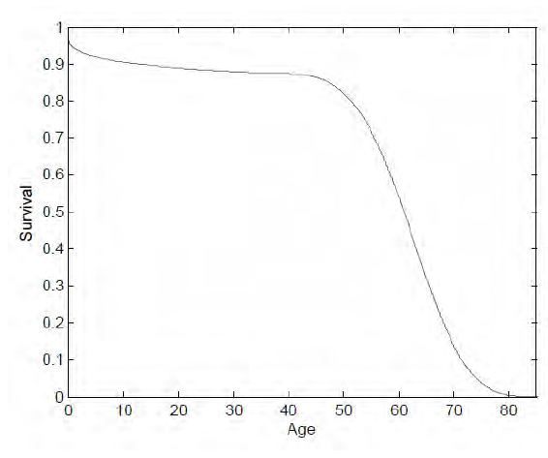

Figure 3: Two stage Weibull survival curve. Mortality is based survival prior to the advent of HIV.

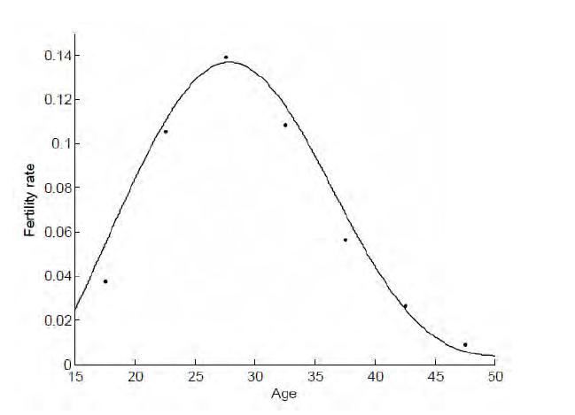

Figure 4: Fertility rates by age.

## Generating output

### Graphs

Simpact has several functions built-in in order to generate various graphs. These can be produced from the “Graphs” menu option. Each is described below along with a sample output:

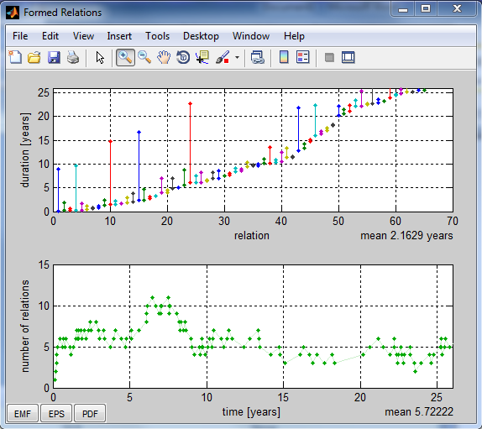

**[What is this telling me?]**

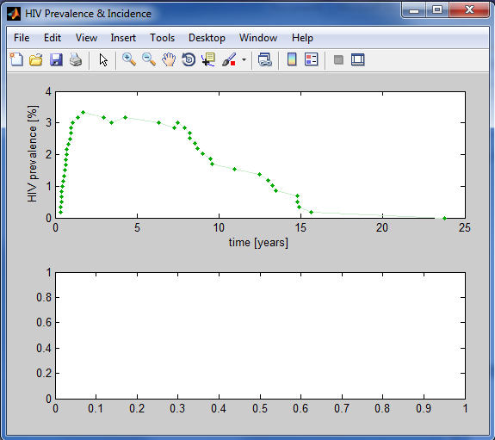

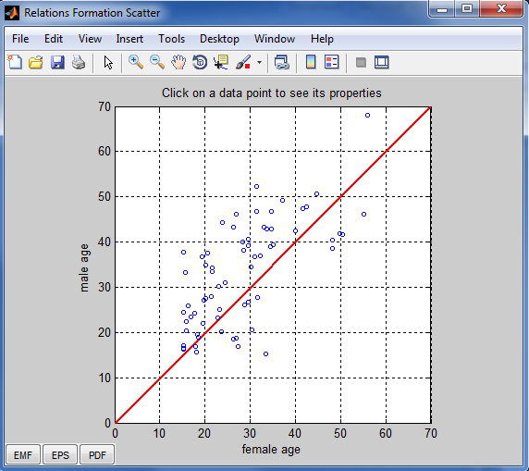

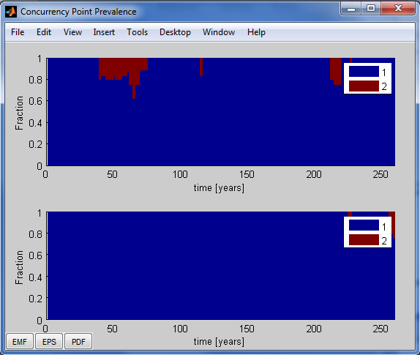

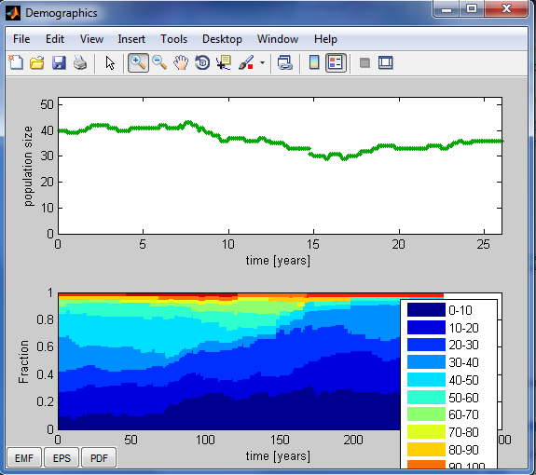

[condom use fraction not implemented yet—but when will it be? (if ever)]

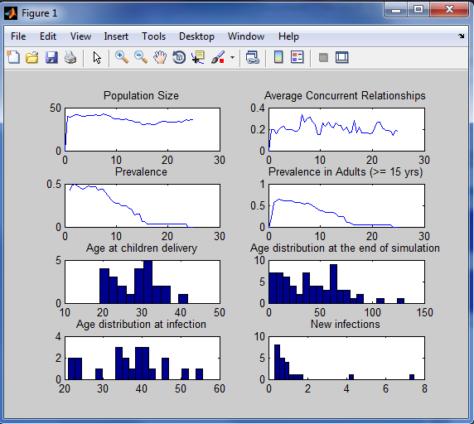

Additionally a user can generate a comma separated values (csv) file with all of the simulated results. To do this select Tools > Export Matrix > CSV. This makes it easy to import into R or your favorite csv reader to make personalized plots and data files. By default, this function creates three csv files in Simpact’s home directory. Please keep this folder neat and move csv files to a subfolder.

The three csv files created pertain to the population of individuals, the relationships of the individuals, and the transmission matrix. Each is described in more detail below.

The user can also move the results directly to the Matlab window via “Model > To MATLAB workspace”. This will export the SDS (Simpact Data Structure) to the command window that was opened with the Simpact GUI. To save the SDS variable to the hard drive type “save SDS”. Again this by default saves to the home directory, and so should consequently be moved a subfolder.

### Population CSV

This csv describes the attributes of each male and each female in the population. Rows 1 through ‘number_of_males’ describe each male, and rows 1+number_of_males through number_of_males+number_of_females describe the females. The table below provides a brief description of each column and what it represents:

|  |  |
| --- | --- |
| Column | Description |
| ID | The unique identifier for the individual |
| gender | The gender: 0 for male, 1 for female |
| father | The ID number of the individual’s father. Those born before the start of the simulation do not have a designated father. |
| mother | The ID number of the individual’s mother. Those born before the start of the simulation do not have a designated mother. |
| born | The simulation time at which the individual was born. Negative numbers indicate that the individual was born before the start of the simulation. For example an individual with a born time of -23.1 indicates that he or she was born 23.1 years before the start of the simulation. An individual with 5.2 indicates that he or she was born 5.2 years into the simulation. |
| deceased | The time of death of the individual in simulation time. Individuals that are still alive at the end of the simulation have a value of NaN. |
| HIV source | The ID number of the individual from whom this individual was infected. Infected individuals with a value of zero indicate that he or she was infected by the HIV_introduction event. |
| HIV positive | The simulation time at which the individual became infected. HIV negative individuals have a value of NaN. |
| AIDS death | The simulation time at which an AIDS related death occurred. |
| HIV test | ??? |
| ARV start | The simulation time for when the individual started ARV treatment??? But what if they start and stop multiple times? |
| ARV stop | The simulation time for when the individual stopped ARV treatment.??? |
| community | 1 ??? |
| BCC exposure | A boolean value that indicates whether they were exposed to the behavioural change campaign. |
| partnering | 1 ??? |
| circumcision | The time at which a male was circumcised. Non-circumcised males and all females have a value of NaN. |
| condom | A boolean value indicating whether this individual consistently uses condoms. ??? This will need to be updated for more sophisticated interventions |
| current relations factor | ? |
| ARV eligible | NaN |
| ARV | 0 |
| HIV test change | NaN |
| CD4Infection | The CD4 count of the individual that infected this rows individual. For example, if row 2 has a CD4infection value of 234, then the individual whose ID is in the HIV source column of row 2 had a CD4 count of 234 when she infected male 1. (The individual in row 2 should be male and have ID 1). |
| CD4ARV | The CD4 count of the individual at ARV initiation. ??? |
| CD4Death | The CD4 count of the individual at time of death. ??? |
| AIDSdeath | Time of death??? We have two… |
| behaviour factor | NaN ??? |
| conception | NaN ??? |
| conceptions | NaN??? |
| sex worker | NaN??? |
| partner 1 | NaN??? |
| start 1 | NaN??? |
| stop 1 | NaN??? |
| partner 2 | NaN??? |
| start 2 | NaN??? |
| stop 2 | NaN??? |
| relationstatustime 1 | NaN??? |
| relationstatustime 2 | NaN??? |
| relationstatustime 3 | NaN??? |
| relationstatustime 4 | NaN??? |
| relationstatus 1 | NaN??? |
| relationstatus 2 | NaN??? |
| relationstatus 3 | NaN??? |
| relationstatus 4 | NaN??? |

### Relations CSV

This csv describes each of the relationships in the simulation. Each row represents a different relationship within the simulation. ???Why are there some relationships with a male ID but not female ID or anything else?

|  |  |
| --- | --- |
| Column | Description |
| maleID | The ID of the male in the relationship. |
| femaleID | The ID of the female in the relationship. |
| start_time | The simulation time at which the relationship started. |
| duration | The amount of time within the simulation that the relationship lasted. |
| male_birth | The simulation time of birth for the male. |
| female_birth | The simulation time of birth for the female. |
| serodicordant_start | A boolean value indicating whether the couple was serodiscordant at the start of the relationship (whether one individual was infected and the other was not.) |
| male_convertion | ??? |
| female_convertion | ??? |

# More Advanced Use

While the GUI for Simpact can be very convenient and easy-to-use, it can be limiting in it’s application. For this reason, using Simpact from a Matlab command line or script may be more useful.

To start a Simpact script, you’ll first need to add the Simpact lib to your path. If you are working from one of Simpacts subfolders (like “fei”, “lucio”, or “wim”) this line should be added to the beginning of your script:

addpath( [fileparts(fileparts(which(mfilename))) '/lib'] )

Of course, you can manually add the path, or use a hard coded path. This is not suggested however since it does easily lend itself to sharing of scripts.

To generate the default SDS (as seen in the GUI) the user can use

[SDS,msg] = modelHIV('new');

From here the parameters of the SDS can be set:

SDS.number_of_males = 10; %set parameters of the model manually

SDS.number_of_females = 10;

SDS.initial_number_of_females = SDS.number_of_females/2;

SDS.initial_number_of_males = SDS.number_of_males/2;

SDS.number_of_relations = 10^2;

Event and intervention specific parameters are within the SDS.events and SDS.interventions substructs:

SDS.interventions.CondomDistribution1.spend_percent_reached = 1000;

SDS.events.ARV_treatment.enable = 0; %disable ARV Treatment

A full list of parameters can be seen by typing SDS into the Matlab window (after running the program). The parameters for an event *e* can be seen by typing SDS.*e*. All parameters are described in “Initial Population Parameters” and “Event Parameters” above. Once all parameters of the model are set you can run the model via:

[SDS2, ~] = spRun('start',SDS); %actually run the model

Once the model has finished various information can be extracted. For example to calculate the cummulative incidence we find the number of HIV positive at each time step:

cum_incidence = zeros(1,20);

for i = 1:20

cum_incidence (i) = length([ find(SDS2.males.HIV_positive<i) find(SDS2.females.HIV_positive<i) ]);

end

A number of common output have been compiled and placed in spData.m. To use spData, supply the output you want and the SDS returned from spRun. For example, to calculate prevalence use:

spData('prevalence',SDS2)

[currently that’s all there is… just prevalence. Additional common output will be added later… by someone.]

1. The algorithm was originally intended to be used for chemical reactions and quanitities of chemicals, therefore terminology is a little different. For instance, we use the term “hazard” instead of “propensity”.
2. Anderson, D. (2007). A modified next reaction method for simulating chemical systems with time dependent propensities and delays. *The Journal of Chemical Physics, 127*.
3. Gillespie, D. (1977). Exact Stochastic Simulation of Coupled Chemical Reactions. *The Journal of Physical Chemistry, 81*(25), 2340-61.
4. Grimm V, Berger U, Bastiansen F, Eliassen S, Ginot V, Giske J, Goss-Custard J, Grand T, Heinz SK, Huse G, Huth A, Jepsen JU, Jørgensen C, Mooij WM, Müller B, Pe'er G, Piou C, Railsback SF, Robbins AM, Robbins MM, Rossmanith E, Rüger N, Strand E, Souissi S, Stillman RA, Vabø R, Visser U, DeAngelis DL (2006): **A standard protocol for describing individual-based and agent-based models.** Ecological Modelling, **198:**115-126.
5. This should be changed to a specific value when used in a paper.
6.